

**DEPT. Of Computer Science Engineering**

**SRM IST, Kattankulathur – 603 203**

**Sub Code & Name: 18CSS201J - ANALOG AND DIGITAL ELECTRONICS**

|  |  |
| --- | --- |
| **Experiment No** | 11 |
| **Title of Experiment** | Applications of Combinational Logic Circuits |
| **Name of the candidate** |  |
| **Register Number** |  |
| **Date of Experiment** |  |

**Mark Split Up**

|  |  |  |  |
| --- | --- | --- | --- |
| **S.No** | **Description** | **Maximum Mark** | **Mark Obtained** |
| 1 | Oral Viva | 5 |  |
| 2 | Execution | 10 |  |
| 3 | Model Calculation / Result Analysis | 5 |  |
| **Total** | | **20** |  |

**Staff Signature with date**

**11.A Seat belt warning system using basic AND & NOT gates**

**Aim**

To demonstrate the applications of combinational logic circuits using AND & NOT gates in a seat belt warning system.

**Apparatus / Software Required:**

MULTISIM SOFTWARE

**Software Required:**

<https://www.multisim.com/>

**Theory**

Combinational logic circuit is an interconnection of logic gates to generate a specified logic function, where the inputs result in an immediate output. This can be easily understood by the following example. The following English expression describes the way a logic circuit should operate in order to drive a seat-belt warning indicator in a car.

*''If the driver is present AND the driver has NOT buckled up AND the ignition switch is on, then the warning light should turn ON.''*

expression

expression

This expression can be easily implemented by using a single- three-input AND gate along with a single NOT gate. This expression could also be implemented by multi-level logic , wherein one gate drives an another gate. In general, we may use two - dual-input AND gates and a single NOT gate. Students need to be cautious and judicious while selecting the gates. As the number of levels increases, the response time of the circuit also increases. Multi-level logic leads to the introduction of more time delay as compared to single-level logic with multiple inputs. If it takes τ seconds for a gate to respond to a change in its input and that gate drives a succeeding gate, then it will take 2τ seconds for the entire circuit to respond. It is desirable to minimize the number of levels in the logic. If one needs to construct a truth table for the same, it can be easily prepared by entering 1's and 0's in that expression for various input combinations.

**TRUTH TABLE:**

| **D** | **B** | **I** | **Y= D. B'. I** |
| --- | --- | --- | --- |
| 0 | 0 | 0 | 0 |
| 0 | 0 | 1 | 0 |
| 0 | 1 | 0 | 0 |
| 0 | 1 | 1 | 0 |
| 1 | 0 | 0 | 0 |
| 1 | 0 | 1 | 1 |
| 1 | 1 | 0 | 0 |
| 1 | 1 | 1 | 0 |

**11.1 APPLICATION: SEAT BELT WARNING SYSTEM IN A CAR**

A seat belt is a safety feature installed in modern vehicles to protect the occupants in case of an accident. However, in some instances, the occupant may start driving the vehicle without fastening the seat belt. This may lead to the violation of safety rules as well as pose risk to the occupants. To indicate that the seat belt has not been buckled, while the ignition switch is turned on, the AND-NOT based indicating system provides a good solution. 1.2 CONCEPT: When the driver turns on the ignition switch without fastening the seat belt, then the warning light glows. This indicates that the seat belt is not buckled or fastened.

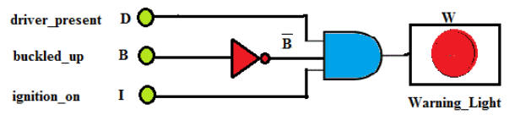

**Figure1. Two Level Logic Seat Belt Warning Light Indicator in a Car**

**Procedure:**

1. Turn On and OFF the three buttons to indicate the status of driver present, buckled off and ignition.
2. Observe for what conditions of the inputs does the RED warning light glow and the alarm is set on.
3. Using simulator build the seat belt warning system and verify the result.

**Circuit Diagram:**

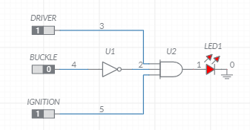

**Figure2. Logic Multisim**

**Verification table:**

|  |  |  |  |
| --- | --- | --- | --- |
| **Status of Driver** | **Seat belt Buckled up** | **Status of Ignition** | **LED Warning** |
| 1 | 0 | 1 |  |
| 1 | 1 | 1 |  |
| 0 | 1 | 0 |  |
|  |  |  |  |
|  |  |  |  |

**Simulation diagram:**

**RESULT**

Thus the Seat belt warning system using basic AND & NOT gates verified with the truth table using Multisim software.

**11.B Car Alarm Control**

**Aim**

To design the application of automobile alarm circuit used to detect certain undesirable conditions

**Apparatus / Software Required:**

MULTISIM SOFTWARE

**Problem Statement:**

Figure 1 shows a diagram for an automobile alarm circuit used to detect certain undesirable conditions. Four sensors are used to indicate day or night (N), the status of the door by the driver's seat (D), the ignition (I) and the headlights (L), respectively. Design the logic circuit with these four sensors as inputs so that the buzzer will be activated whenever any of the following conditions exist:

• The headlights are ON while the ignition is OFF

• The door is OPEN while the ignition is ON

• The headlights are OFF at night when ignition is ON.

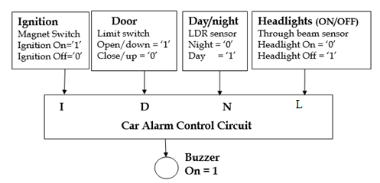

**Software Required:**

<https://www.multisim.com/>

**TRUTH TABLE:**

|  |  |  |  |  |
| --- | --- | --- | --- | --- |
| I | D | N | L | Buzzer |
| 0 | 0 | 0 | 0 | 1 |
| 0 | 0 | 0 | 1 | 0 |
| 0 | 0 | 1 | 0 | 1 |
| 0 | 0 | 1 | 1 | 0 |
| 0 | 1 | 0 | 0 | 1 |
| 0 | 1 | 0 | 1 | 0 |
| 0 | 1 | 1 | 0 | 1 |
| 0 | 1 | 1 | 1 | 0 |
| 1 | 0 | 0 | 0 | 0 |
| 1 | 0 | 0 | 1 | 1 |
| 1 | 0 | 1 | 0 | 0 |
| 1 | 0 | 1 | 1 | 0 |
| 1 | 1 | 0 | 0 | 1 |
| 1 | 1 | 0 | 1 | 1 |
| 1 | 1 | 1 | 0 | 1 |
| 1 | 1 | 1 | 1 | 1 |

**K map:**

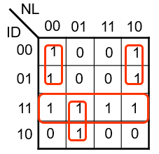

**Logic equation:**



**Procedure:**

1. Build the logic circuit in simulator
2. In buzzer properties, change the voltage as 2V and current as 1mA (The output voltage from the logic circuit is 3.3 V, This is shared between LED and Buzzer).
3. Turn On and OFF the Four buttons to indicate the day or night (N), the status of the door by the driver's seat (D), the ignition (I) and the headlights (L), respectively.
4. Observe for which status of the inputs, the RED warning light is turned ON and the buzzer is set on.
5. Verify the result using this automobile alarm circuit.

**Circuit Diagram:**

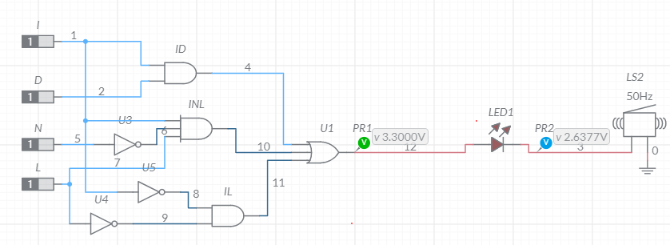

**Figure3. Logic Circuit-Multisim**

**Simulation diagram:**

**RESULT**

Thus, the given applications where verified with the designed logic circuits and truth table using Multisim software.